Stored procedures are reusable SQL code snippets that encapsulate complex business logic, allowing for efficient execution and parameter passing. They can be created in various database systems, such as SQL Server and PostgreSQL, and are used to execute multiple SQL statements in a structured manner.
Key points about stored procedures include:

Definition: A stored procedure is a prepared SQL code that can be saved for reuse, making it easier to execute SQL queries repeatedly.

Parameters: Stored procedures can accept parameters, allowing them to respond to different input values.

Execution: They can be executed using the RUN STORED-PROCEDURE statement in SQL Server, which allows for error handling and parameter passing.

Monitoring: Stored procedures can be monitored for execution history, performance metrics, and security auditing.

I use Stored procedures for last test :
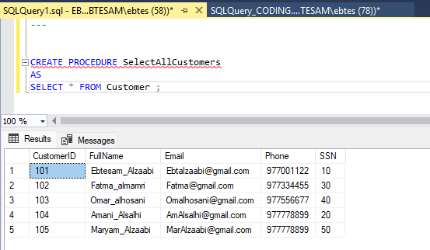

An SQL transaction is a sequence of one or more SQL operations (e.g., INSERT, UPDATE, DELETE) executed as a single unit of work. Transactions ensure that either all operations succeed or none are applied, maintaining data integrity.

